1-1-2: Hot Backup – Bryan Mack

1. Create a folder named hotBackups

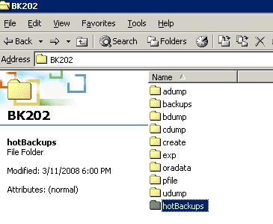

2. Determine the location of your datafiles

SQL> select name from v$datafile;

NAME
----------------------------------------------------------------
C:\MSCD642\DBMS\APP\ADMIN\BK202\ORADATA\DISK1\SYSTEM01.DBF
C:\MSCD642\DBMS\APP\ADMIN\BK202\ORADATA\DISK1\UNDOTBS01.DBF
C:\MSCD642\DBMS\APP\ADMIN\BK202\ORADATA\DISK2\SYSAUX01.DBF
C:\MSCD642\DBMS\APP\ADMIN\BK202\ORADATA\DISK2\USERS01.DBF

SQL> select member from v$logfile;

MEMBER
----------------------------------------------------------------
C:\MSCD642\DBMS\APP\ADMIN\BK202\ORADATA\DISK5\REDO03.LOG
C:\MSCD642\DBMS\APP\ADMIN\BK202\ORADATA\DISK4\REDO02.LOG
C:\MSCD642\DBMS\APP\ADMIN\BK202\ORADATA\DISK3\REDO01.LOG

SQL> select name from v$controlfile;

NAME
----------------------------------------------------------------
C:\MSCD642\DBMS\APP\ADMIN\BK202\ORADATA\DISK3\CTRL1.CTL
C:\MSCD642\DBMS\APP\ADMIN\BK202\ORADATA\DISK4\CTRL2.CTL
C:\MSCD642\DBMS\APP\ADMIN\BK202\ORADATA\DISK5\CTRL3.CTL

3. Ensure your database is in archivelog mode

SQL> select log_mode from v$database;

LOG_MODE
------------
NOARCHIVELOG

SQL> shutdown immediate
Database closed.
Database dismounted.
ORACLE instance shut down.
SQL> startup mount
ORACLE instance started.

Total System Global Area 100663296 bytes
Fixed Size 1247492 bytes
Variable Size 58722044 bytes
Database Buffers 33554432 bytes
Redo Buffers 7139328 bytes
Database mounted.
SQL> alter database archivelog;

Database altered.

SQL> alter database open;

Database altered.

SQL> select log_mode from v$database;

LOG_MODE
------------
ARCHIVELOG

4. SQL> alter database begin backup;

SQL> alter database begin backup;

Database altered.

5. Copy the files identified in step one to the hotBackups folder

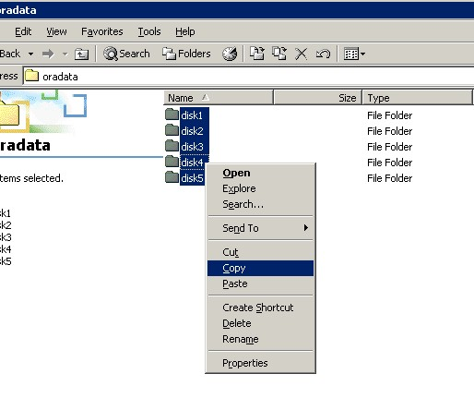
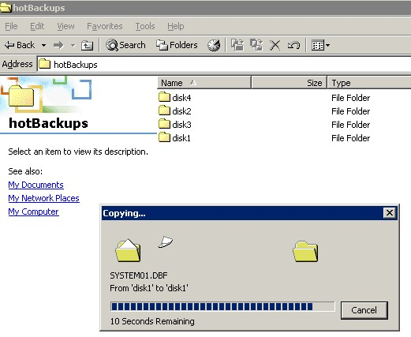

6. SQL> alter database end backup;

SQL> alter database end backup;

Database altered.

